Para incluir tanto el texto del header como una imagen en un dataView

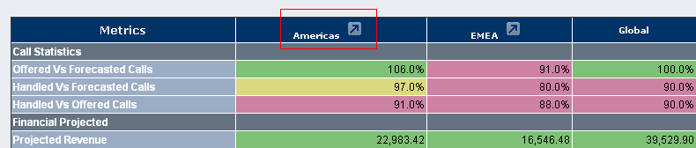

For i = 1 To data1.HeaderRow.Cells.Count - 1

Dim imagen As Image

imagen = New Image()

imagen.ImageUrl = "~/images/arrow.gif"

data1.HeaderRow.Cells(i).Controls.Add(imagen)

Next

**Es necesario crear una imagen nueva en cada occasion sino solo pone la imagen en el ultimo que la utiliza.**

**Otra opcion mas corta**

Dim Titles As string

For i = 1 To data1.HeaderRow.Cells.Count - 1

Titles = data1.HeaderRow.Cells(i).Text

data1.HeaderRow.Cells(i).Text= Titles + "<img src='../images/arrow.gif'>"

Next

**La opcion de sorting se deshabilita, para agregar la opcion de sorting para la imagen se agrega**

strTitle = strTitle.ToUpper

If strTitle = "ASIA" Or strTitle = "US" Or strTitle = "CALA" Then

Condicion = "SubRegion=" + strTitle + "&Choice=Sites&iMonth=" + strMonth + "&iYear=" + strYear

strWindow = "window.open(""KPI_PopUp.aspx?" + Condicion + """,""SubRegion"", ""titlebar=yes,status=yes,toolbar=no,menubar=no,location=no,scrollbars=yes,resizable=yes"");"

data1.HeaderRow.Cells(i).Text="<img src='../images/" + strTitle + ".gif' **onclick**='" + strWindow + "'>"

End If

En el HTML solo reconoce HTML y java pero si desea llamar a una funcion de .NET seria

<http://msdn.microsoft.com/en-us/library/ms223395.aspx>

**Protected Sub Page_Load(ByVal sender As Object, ByVal e As System.EventArgs)**

If (IsPostBack) Then Exit Sub

Dim cs As ClientScriptManager

Dim cbReference As String

Dim callbackScript As String

cs = Page.ClientScript

cbReference = cs.GetCallbackEventReference("'" & _

Page.UniqueID & "'", "arg", "**ReceiveFX**", "", "**ErrorFX**", False)

callbackScript = "function CallTheServer(arg, context) {" & cbReference & "; } "

cs.RegisterClientScriptBlock(Me.GetType(), "CallTheServer",callbackScript, True)

**End Sub**

**Protected Overrides Sub Render(ByVal writer As System.Web.UI.HtmlTextWriter)**

Page.ClientScript.RegisterForEventValidation(button1.UniqueID, Me.ToString())

MyBase.Render(writer)

**End Sub**

' -------------------------------

Dim cbMessage As String = ""

' Define method that processes the callbacks on server.

Public Sub RaiseCallbackEvent(ByVal eventArgument As String) _

Implements System.Web.UI.ICallbackEventHandler.RaiseCallbackEvent

Try

Page.ClientScript.ValidateEvent(button1.UniqueID, Me.ToString())

cbMessage = "Correct event raised callback."

Catch ex As Exception

cbMessage = "Incorrect event raised callback."

End Try

End Sub

' Define method that returns callback result.

Public Function GetCallbackResult() As String Implements System.Web.UI.ICallbackEventHandler.GetCallbackResult

Return cbMessage

End Function

' -------------------------------

</script>

<script type="text/javascript">

var value1 = new Date();

function **ReceiveFX**(arg, context)

{

Message.innerText = arg;

Label1.innerText = "Callback completed at " + value1;

value1 = new Date();

}

function **ErrorFX**(arg, context)

{

Message.innerText = 'An error has occurred.';

}

</script>

<input type="button" id="**button1**" runat="server"

value="ClientCallBack"

onclick="CallTheServer(value1, null )"/>